Bioreactor (Theory)

Objective: To understand the basic design and operation features of the bioreactor.

Theory: Key parts of the bioreactor are described below:

Bioreactor – can be described as a vessel which has provision of cell cultivation under sterile condition & control of environmental conditions e.g., pH, Temperature, Dissolved oxygen etc. It can be used for the cultivation of microbial plant or animal cells. A typical bioreactor consists of following parts.

Agitator – This facilitates the mixing of the contents of the reactor which eventually keeps the “cells” in the perfect homogenous condition for better transport of nutrients and oxygen for adequate metabolism of cell to the desired product(s).

The agitator can be top driven or bottom which could be basically magnetic / mechanically driven. The bottom driven magnetic /mechanical agitators are preferred as opposed to top driven agitators as it saves adequate space on the top of the vessel for insertion of essential probes (Temperature, pH, dissolved oxygen foam, Co₂ etc) or inlet ports for acid, alkali, foam, fresh media inlet /exit gases etc. However mechanical driven bottom impellers need high quality mechanical seals to prevent leakage of the broth.

Baffle – The purpose of the baffle in the reactor is to break the vortex formation in the vessel, which is usually highly undesirable as it changes the centre of gravity of the system and consumes additional power.

Sparger – In aerobic cultivation process the purpose of the sparger is to supply oxygen to the growing cells. Bubbling of air through the sparger not only provide the adequate oxygen to the growing cells but also helps in the mixing of the reactor contents thereby reducing the power consumed to achieve a particular level of (mixing) homogeneity in the culture.

Jacket – The jacket provides the annular area for circulation of constant temperature water which keeps the temperature of the bioreactor at a constant value. The desired temperature of the circulating water is maintained in a separate Chilled Water Circulator which has the provision for the maintenance of low/high temperature in a reservoir. The contact area of jacket provides adequate heat transfer area wherein desired temperature water is constantly circulated to maintain a particular temperature in the bioreactor.

Basic control systems for the operation of the bioreactor are described below:

Temperature Measurement and control – The measurement of the temperature of the bioreactor is done by a thermocouple or Pt -100 sensor which essentially sends the signal to the Temperature controller. The set point is entered in the controller which then compares the set point with the measured value and depending on the error, either the heating or cooling finger of the bioreactor is activated to slowly decrease the error and essentially bring the measured temperature value close to the set point.

pH measurement and control – The measurement of pH in the bioreactor is done by the autoclavable pH probe. The measured signal is compared with the set point in the controller unit which then activates the acid or alkali to bring the measured value close to the set point. However before the pH probe is used, it needs to be calibrated with two buffers usually in the pH range which is to be used in the bioreactor cultivation experiment. The probe is first inserted in (let us say) pH 4 buffer and the measured value is corrected by the zero knob of the controller. Thereafter the probe is put in pH 7 buffer and if needed the measured value is corrected by the asymmetry knob of the controller. The pH probe is now ready for use in the range 0-7 pH range.

Identification of pH controller control settings for Bio-Engineering AG (Switzerland) bioreactor – For this specific pH controller one has to suitably identify the right control action setting for the addition of certain concentration of acid / alkali in the desired fermentation broth which can give quick control action with-out any oscillations/offset of measured value around the set point. The controller panel and the different knobs are adequately described in the following figure –

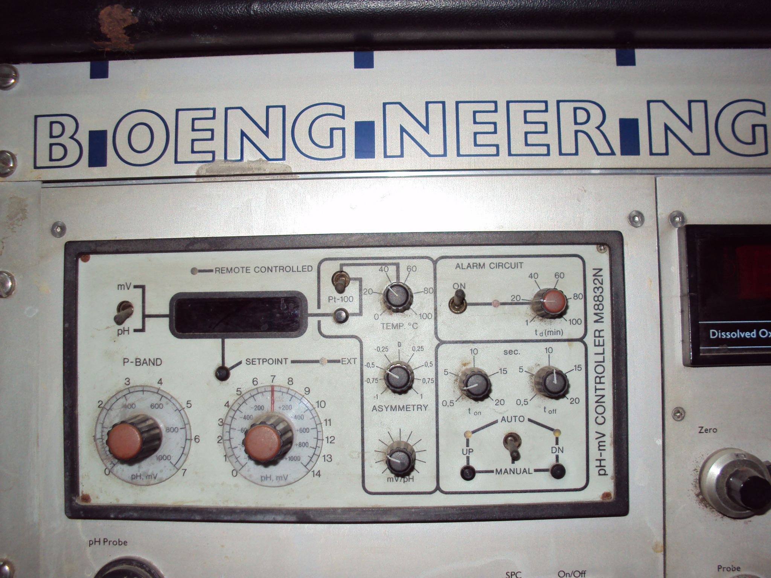

Before the start of autoclaving of the broth for any cultivation experiment, it is essential to calibrate the pH probe (as described above). Thereafter the set point (say 5) and p-band (1.0) is entered on the controller. This essentially means that now the pH controller will control the pH value in the range 4.0 to 6.0 For example if the measured pH value in the bioreactor is 4.5 then the controller will trigger alkali addition to the reactor to bring the measured value to 5.0 and similarly if the pH value is 5.5 it activates the acid pump to bring down the pH value to the set point. It is ensured that the p-band value is not kept too small or else it may lead to oscillation of the measured value around the set point similarly if the p-band is too large then it may give rise to offset between the measured value and set point of the controller. It may also be noted that the activation of acid/alkali pumps is done in a phased manner. For example if the controller is adding alkali to bring down the pH, the addition of the alkali is not done in one shot. In fact the alkali addition pump is kept on for some time and then it is off for some time. This ensures adequate mixing of first installment of acid/alkali in the broth before next installment is added. This strategy avoids over addition of acid/alkali for the pH control. The On/Off time of the controller has to be adjusted by separate experiments and will depend on the buffering capacity of the broth, concentration of acid/alkali etc. However it is absolutely essential to identify & maintain these setting before the start of the experiment in order to have efficient control action of the control which features stable quick control action with-out oscillations &/or off set around set point. There is another knob t_{d} in the control panel which provides the setting of the safety time during which if the control action is not achieved it raises the alarm for the operator.

Dissolved oxygen controller – The dissolved oxygen in the bioreactor broth is measured by a dissolved oxygen probe which basically generates some potential corresponding to the dissolved oxygen diffused in the probe. Before the measurement can be done by the probe it is to be calibrated for its zero and hundred percent values. The zero of the probe is set by (zero knob) the measured value of the dissolved oxygen when the broth is saturated with nitrogen purging. Similarly the hundred percent of the instrument is calibrated by the measured value of dissolved oxygen when broth is saturated with purging air in it. After calibration the instrument is ready for the measurement of the dissolved oxygen in the broth. In the event of low oxygen in the fermentation broth, more oxygen can be purged in the bioreactor &/or stirrer speed can be increased to enhance the beating of the bubbles which essentially enhances the oxygen transfer area and net availability of oxygen in the fermentation broth.

Foam control – The fermentation broth contains a number of organic compounds and the broth is vigorously agitated to keep the cells in suspension and ensure efficient nutrient transfer from the dissolved nutrients and oxygen. This invariably gives rise to lot of foam. It is essential that control of the foam is done as soon as possible.

